ECE 3332 – 301
Train Car Sorter

Amna Malik, Computer Engineer
Dylan Iden, Electrical Engineer
Cannon Thomas, Computer Engineer
Texas Tech University
Electrical and Computer Engineering Department
May 2026

Abstract
This project presents the design and implementation of an RFID-based automated train sorting system capable of identifying and routing train cars to designated tracks. The system integrates Digital Command Control (DCC), RFID sensing hardware, embedded control circuitry, and a Python-based graphical user interface (GUI) to automate locomotive movement and monitor track occupancy in real time. RFID tags mounted beneath train cars are detected by readers positioned beneath the track, allowing the system to determine train car identity and routing assignments. The GUI supports both manual and automatic operating modes while providing turnout control, occupancy monitoring, and locomotive operation. Additional features include custom PCB hardware and 3D-printed scenery components integrated into the physical railway layout. The completed system successfully demonstrates automated train routing, real-time occupancy detection, and embedded hardware/software integration within a functional railway automation platform.

Table of Contents
1. Introduction 1
2. System Overview 2
2.1 Hardware Components 2
2.2 Software Framework 3
3. Design and Implementation 6
4. Testing and Results 12
5. Engineering Standards and IP Considerations 13
6. Safety and Welfare Considerations 14
7. Global, Social, and Economic Impacts 15
8. Conclusion 15
References 17
Appendix A: Gantt Chart 18
Appendix B: Budget 19

List of Figures
Figure 1: Full train sorting system layout. 1
Figure 2: Overall hardware layout of the automated train sorting system. 3
Figure 3: Full graphical user interface used for train routing, turnout control, RFID monitoring, and locomotive operation. 4
Figure 4: GUI displaying RFID-based track occupancy detection. 5
Figure 5: GUI occupancy monitoring and track status display. 6
Figure 6: RFID reader modules positioned beneath rail cars for occupancy detection. 8
Figure 7: Custom PCB used for turnout control and signal distribution. 10
Figure 8: Integrated physical layout with decorative scenery and lighting. 11
Figure 9: Victory loop with integrated scenery, lighting, and locomotive operation. 13

Introduction
Railway automation systems are commonly used to improve routing efficiency, cargo organization, and operational safety. This project demonstrates a scaled automated train sorting system using RFID sensing, Digital Command Control (DCC), and embedded control hardware to identify and route train cars throughout a multi-track railway layout.
RFID tags mounted beneath individual rail cars are detected by readers positioned beneath designated track sections. Detection data is transmitted to a Python-based graphical user interface (GUI), allowing the system to monitor track occupancy and assist with turnout routing decisions in real time. Electrically actuated turnout switches direct train cars toward assigned sorting tracks during operation.
The layout also incorporates a continuous “victory loop” used for demonstration operation alongside custom 3D-printed scenery components including utility poles, decorative trees, lighting elements, track barriers, and a central mountain structure shown in Figure 1.
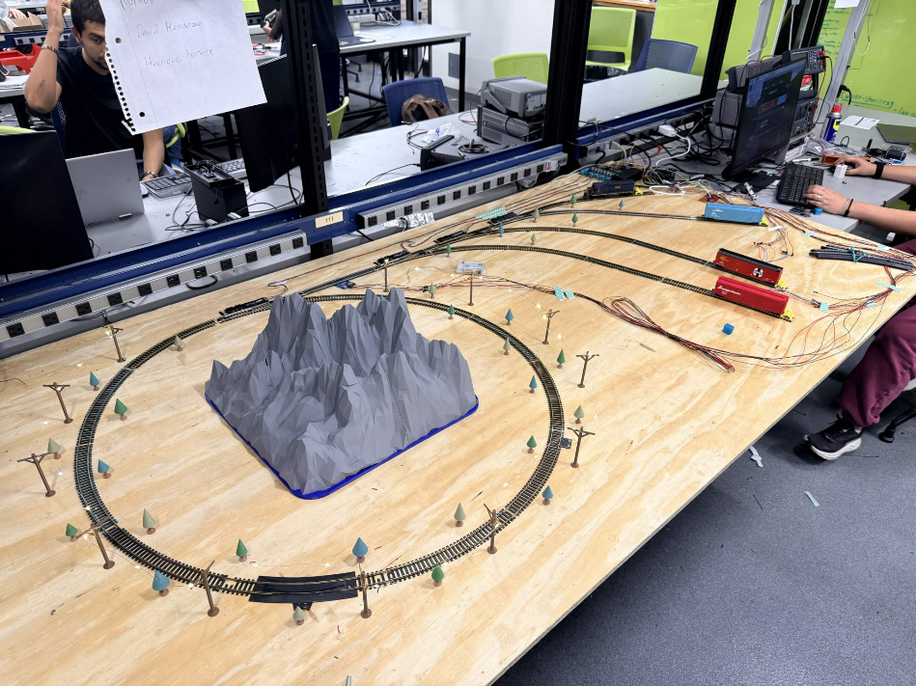
Figure 1: Full train sorting system layout.

System Overview
The automated train sorting system consists of multiple interconnected hardware and software subsystems responsible for train identification, routing, occupancy monitoring, and locomotive control. The system combines RFID sensing hardware, Digital Command Control (DCC), turnout switching mechanisms, and a Python-based graphical user interface to create a fully integrated train sorting platform. The following sections describe the primary hardware and software components used throughout the system.

2.1 Hardware Components
The hardware infrastructure of the automated train sorting system consists of several interconnected subsystems responsible for locomotive control, turnout switching, RFID detection, occupancy monitoring, and power distribution. The layout contains a primary locomotive path, multiple sorting tracks, RFID detection regions, and electronically actuated turnout switches used to direct train cars toward assigned destinations.
A Raspberry Pi is used as the primary control platform and communicates with the turnout control hardware and graphical user interface. RFID readers positioned beneath the track detect RFID tags mounted underneath individual train cars, allowing the system to identify train occupancy and routing assignments in real time.
Additional hardware components include DCC locomotive control hardware, turnout switching circuitry, occupancy sensing components, and custom PCB hardware used for signal distribution and turnout actuation. The physical layout also incorporates several custom 3D-printed scenery components including utility poles, decorative trees, track barriers, and a large mountain structure surrounding the victory loop section of the layout
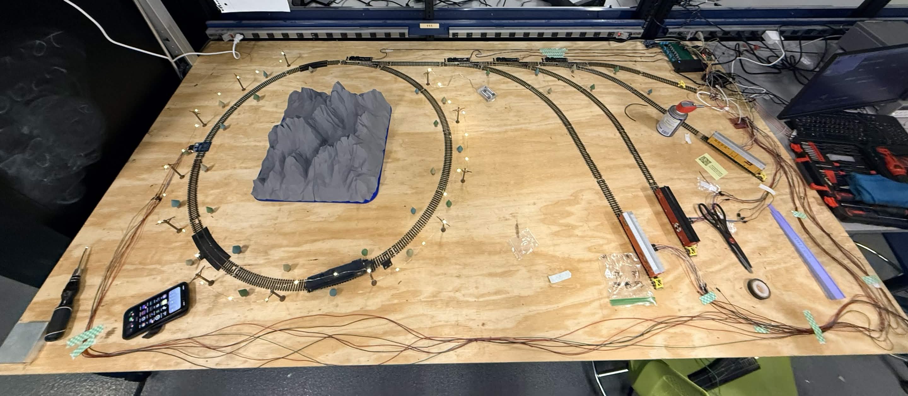
Figure 2: Overall hardware layout of the automated train sorting system.
Figure 2 shows the completed routing layout and integrated hardware platform used throughout testing and demonstration operation. The system combines embedded control hardware, turnout switching components, RFID sensing infrastructure, and decorative scenery components into a unified automated railway platform.

2.2 Software Framework
The software framework of the train sorting system is centered around a Python-based graphical user interface (GUI) used for train control, occupancy monitoring, and automated routing operation. The GUI continuously processes RFID detection information and displays track occupancy states in real time.
The interface supports both manual and automatic operating modes. Manual controls allow operators to directly toggle turnout switches, control locomotive movement, and monitor track occupancy conditions. Automatic mode enables the system to identify train cars using RFID detections and automatically route them toward assigned sorting tracks.
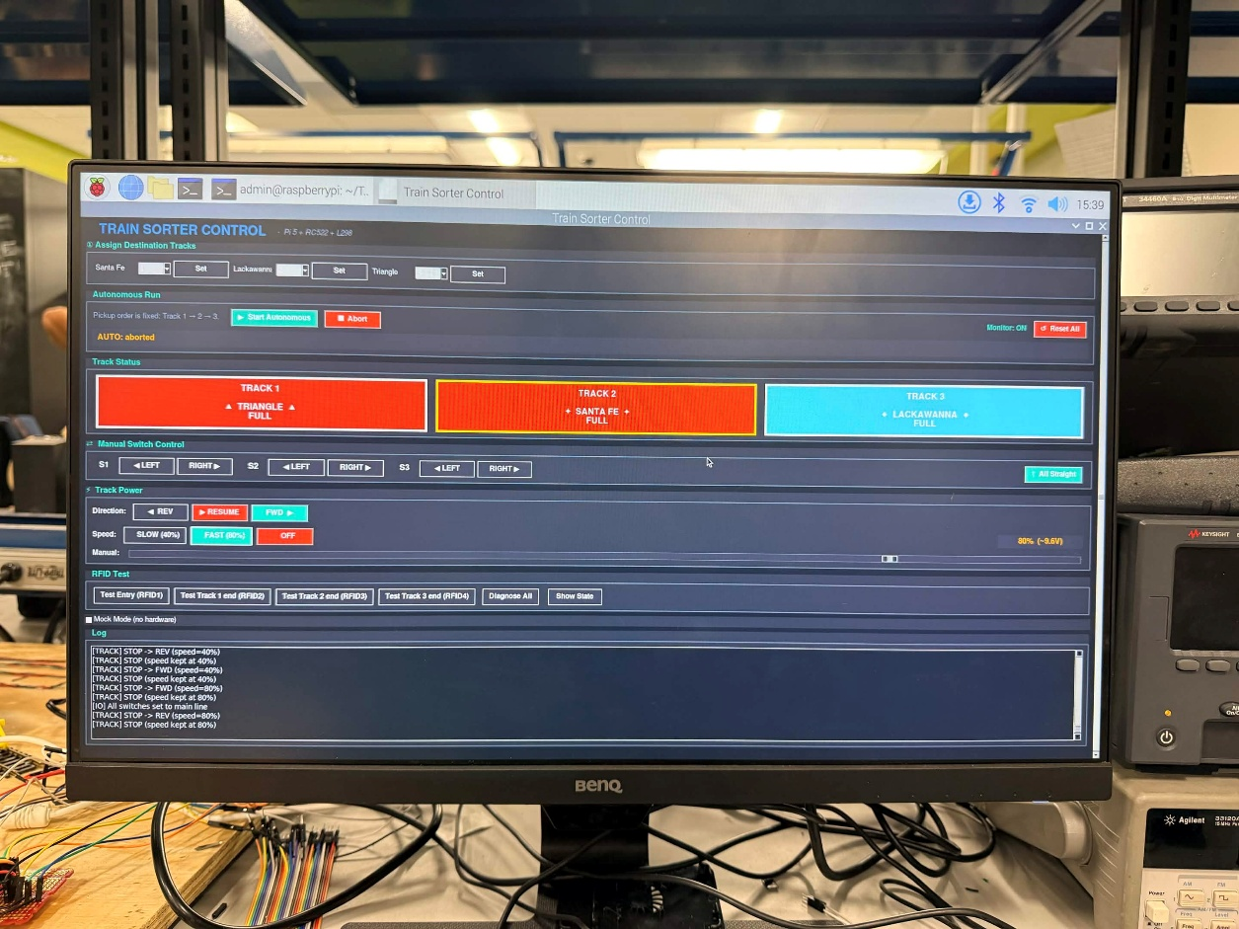
Figure 3: Full graphical user interface used for train routing, turnout control, RFID monitoring, and locomotive operation.
Real-time occupancy updates are displayed within the interface whenever an RFID-equipped train car passes over a reader. The GUI also displays routing status information and turnout states during active train operation. The interface also provides manual turnout controls, locomotive speed adjustment, and real-time routing feedback during testing and demonstrations.

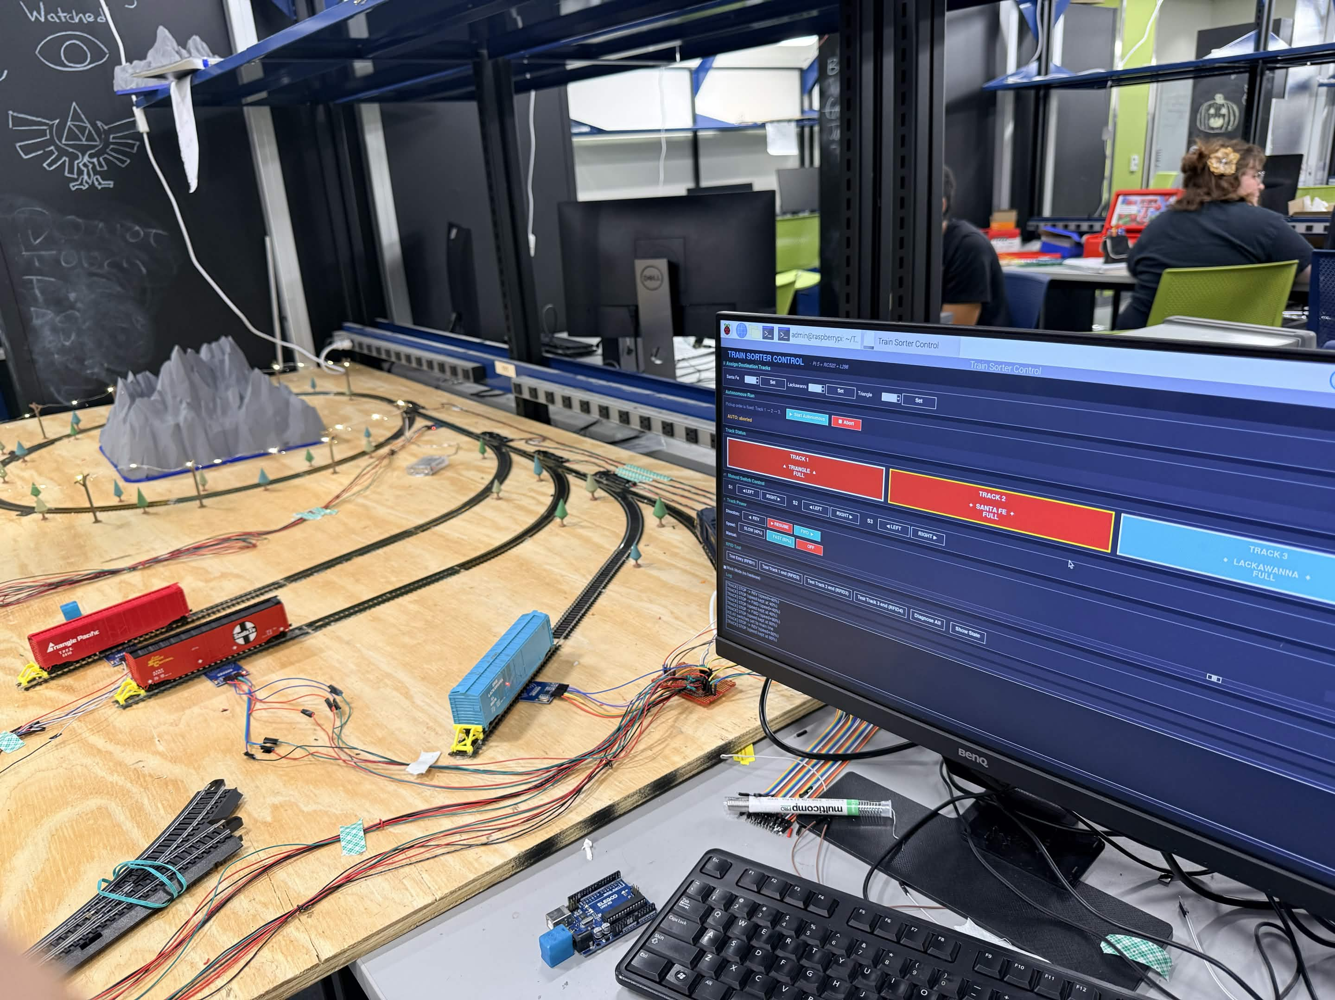
Figure 4: GUI displaying RFID-based track occupancy detection.
Figure 4 shows the real-time occupancy updates are displayed within the interface whenever an RFID-equipped train car passes over a reader. The GUI also displays routing status information and turnout states during active train operation.
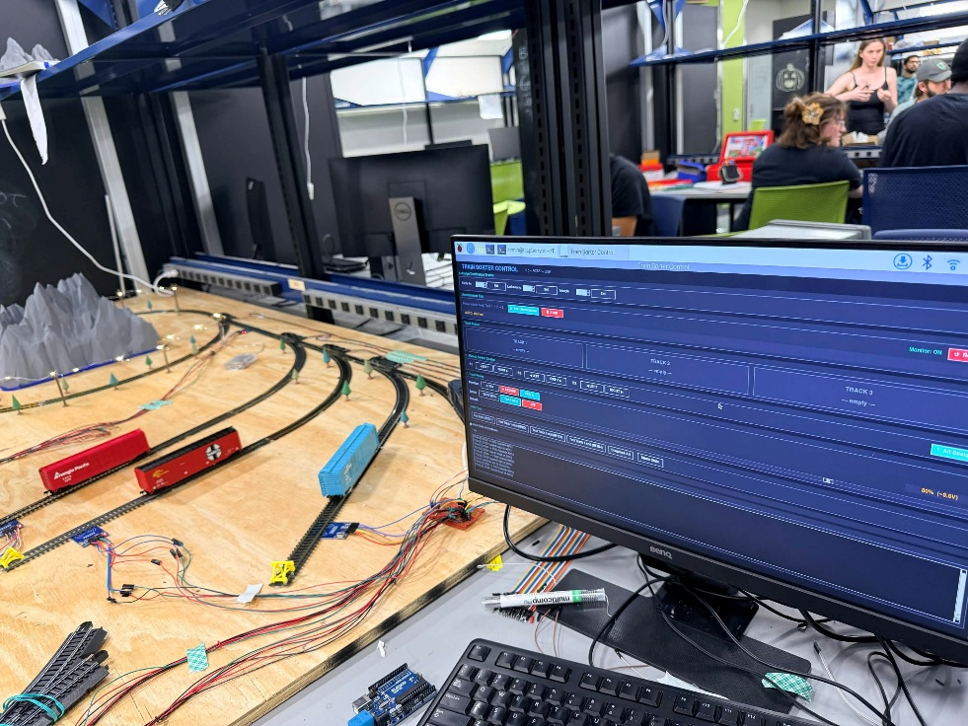
Figure 5: GUI occupancy monitoring and track status display.
Figure 5 demonstrates the occupancy monitoring interface during operation with unoccupied track states. The software framework was designed to simplify system operation while providing continuous feedback during testing, routing validation, and live demonstration of the automated sorting system.

Design and Implementation
The design and implementation phase focused on integrating RFID sensing hardware, turnout switching systems, occupancy monitoring, and locomotive control into a unified automated routing platform. The completed system combines embedded hardware, software control logic, and physical railway infrastructure to automate train sorting operations while maintaining continuous locomotive movement throughout the layout.
The following sections describe the primary implementation features of the automated train sorting system including RFID detection, turnout routing control, graphical user interface operation, and physical system integration.
3.1 RFID Identification System
The RFID detection system was designed to identify individual train cars and provide real-time occupancy information to the control software. Passive RFID tags were mounted beneath each train car while RFID readers were positioned beneath designated sections of the track layout.
During operation, RFID readers continuously monitor for nearby tags as train cars pass through the detection regions. When a tag is detected, the identification value is transmitted to the GUI and associated with the corresponding train car assignment. This allows the system to monitor track occupancy conditions and determine appropriate routing behavior for each rail car.
The RFID detection process also enables the software to distinguish between occupied and unoccupied sorting tracks during automated operation. This functionality improves routing reliability and prevents train cars from being directed toward already occupied tracks.
Figure 6: RFID reader modules positioned beneath rail cars for occupancy detection.
Figure 6 shows RFID reader modules positioned beneath the track sections used for occupancy detection and rail car identification. Each rail car contains an RFID tag mounted underneath the chassis, allowing the system to determine track occupancy and routing assignments in real time.
3.2 Track Switching Mechanism
The routing system utilizes electronically actuated turnout switches to direct train cars toward assigned sorting tracks. Multiple turnout switches are arranged throughout the layout to form a branching routing structure capable of distributing train cars across several output tracks.
Turnout states are controlled through software commands generated by the GUI and routing logic. Based on RFID detection information and current occupancy conditions, the system determines the required turnout configuration needed to guide the locomotive and attached train cars toward the correct destination track.
The turnout routing network supports both manual and automatic operating modes. Manual mode allows direct operator control of turnout positions while automatic mode dynamically adjusts turnout states according to train car routing assignments and occupancy monitoring conditions.
3.3 PCB and Control Hardware
A custom printed circuit board (PCB) was developed to simplify turnout control wiring and improve electrical organization throughout the train sorting system. The PCB distributes control signals and power connections to multiple turnout switching components while reducing wiring complexity across the layout.
The board incorporates multiple transistor-based switching circuits used to actuate turnout hardware and interface with the embedded control system. Connector terminals were integrated into the design to support modular wiring, simplify maintenance, and improve hardware accessibility during testing and debugging.
The PCB also assists with signal routing and centralized hardware integration by reducing loose wiring connections between turnout hardware, occupancy monitoring components, and control circuitry.
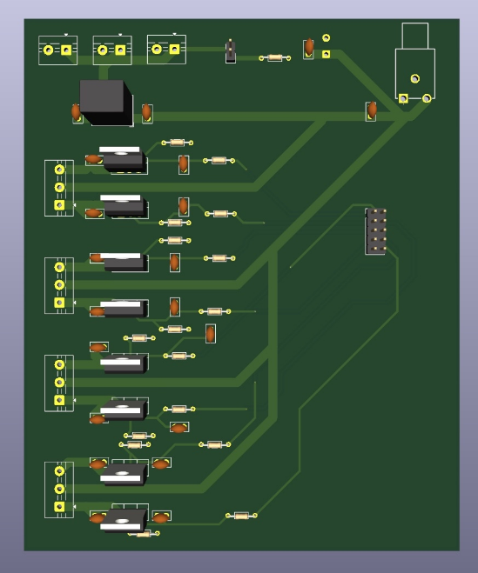
Figure 7: Custom PCB used for turnout control and signal distribution.
Figure 7 shows the custom PCB developed for electrical signal distribution and turnout control integration throughout the automated train sorting system. The PCB centralizes wiring connections between the control hardware, occupancy monitoring components, and track switching circuitry.
3.4 System Integration
The physical layout combines the routing infrastructure, embedded hardware, occupancy monitoring components, and decorative scenery into a unified automated railway environment. Wiring for RFID readers, turnout switches, occupancy sensors, and DCC hardware was integrated throughout the platform to support reliable system operation during testing and demonstration.
Several custom 3D-printed scenery components were incorporated into the final layout including utility poles, decorative trees, track barriers, and a large mountain structure positioned within the victory loop section of the track layout. Decorative lighting was also added around the loop to improve presentation quality and enhance overall visual appearance during demonstrations.
The integrated system supports continuous locomotive operation while simultaneously demonstrating automated occupancy monitoring, turnout routing, and RFID-based train car identification.
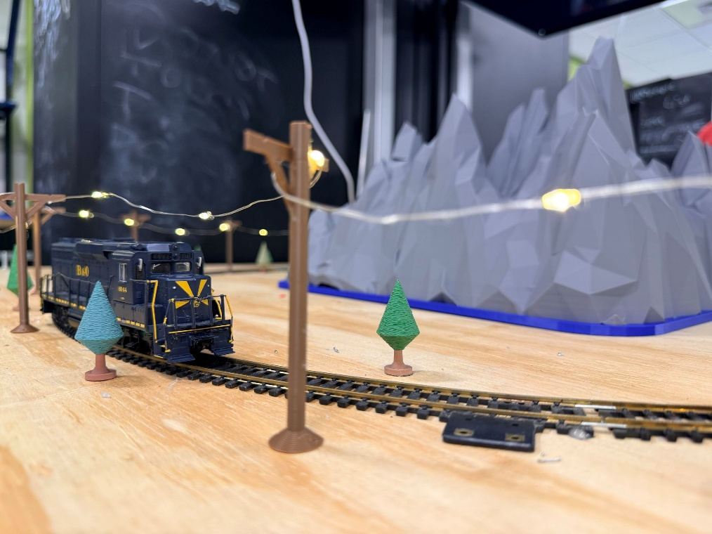
Figure 8: Integrated physical layout with decorative scenery and lighting.
Figure 8 demonstrates the fully integrated automated train sorting layout including the locomotive routing system, decorative scenery, utility poles, lighting elements, and mountain structure surrounding the victory loop. The integrated layout combines hardware functionality with visual presentation to create a complete railway automation demonstration platform.

Testing and Results
Testing was performed to evaluate the operation of the automated train sorting system including RFID detection, turnout switching, graphical user interface (GUI) communication, and locomotive routing. The locomotive was operated throughout the primary routing path and continuous victory loop to verify electrical continuity, turnout response, and reliable train movement during both manual and automatic operating modes.
The turnout switching system was tested using both manual operator commands and automated routing commands generated by the control software. During operation, turnout states successfully redirected the locomotive and attached rail cars toward designated sorting tracks. The turnout network demonstrated reliable routing performance throughout repeated switching cycles and occupancy monitoring tests.
RFID occupancy monitoring was evaluated using rail cars equipped with passive RFID tags mounted beneath each rail car. RFID reader modules positioned beneath designated track sections successfully detected nearby rail cars and transmitted occupancy information to the GUI in real time. The software interface dynamically updated occupied and unoccupied track states during testing while simultaneously displaying routing information and turnout status conditions.
Integrated system testing combined RFID occupancy monitoring, turnout routing, locomotive control, GUI communication, and decorative system integration into a unified automated railway platform. The system successfully demonstrated automatic occupancy tracking, turnout state monitoring, and continuous locomotive movement throughout the routing layout while maintaining stable communication between hardware and software subsystems.
Additional testing included operation of decorative lighting elements and custom 3D-printed scenery components during active train demonstrations. Utility poles, decorative lighting, trees, track barriers, and the central mountain structure remained mechanically stable throughout locomotive operation while improving the overall presentation quality of the automated railway environment.
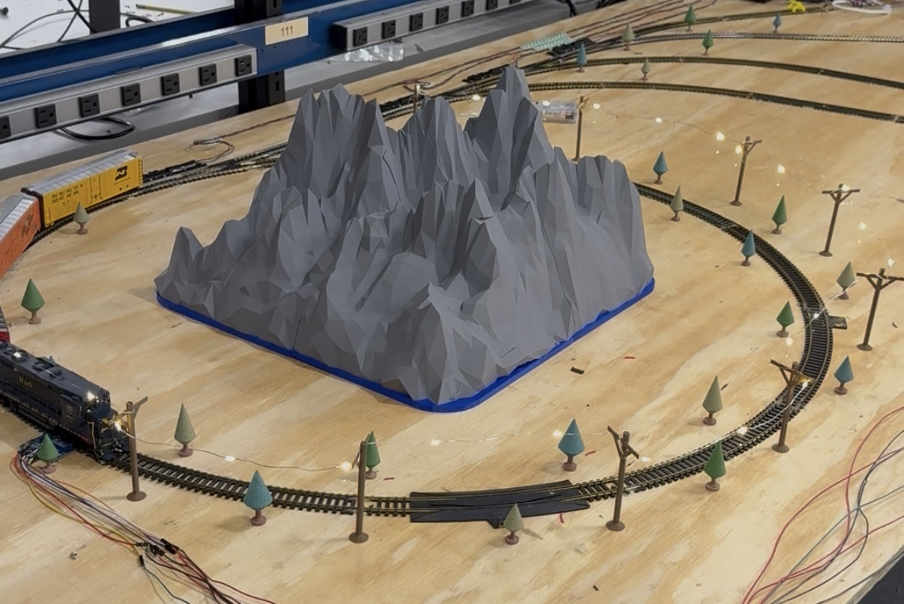
Figure 9: Victory loop with integrated scenery, lighting, and locomotive operation.
Figure 9 demonstrates the completed victory loop section of the automated train sorting layout including integrated lighting, 3D-printed scenery, utility poles, decorative trees, and continuous locomotive operation.
The mountain structure was positioned within the center of the loop to improve visual presentation while maintaining unobstructed rail movement throughout demonstrations and testing.

Engineering Standards and IP Considerations
The design and documentation of this project follow IEEE reporting and documentation standards to improve organization, readability, and reproducibility. Digital Command Control (DCC), a widely used standard for controlling model locomotives through digital communication over the rail system, was implemented for locomotive operation and movement control throughout the layout.
RFID technology was integrated using commercially available passive RFID tags and reader modules commonly used in embedded identification and occupancy monitoring applications. Electrical wiring and turnout control hardware were designed to support modular integration and maintainable system organization during testing and demonstration.
The software framework for the graphical user interface was developed using Python and open-source software libraries. All custom PCB layouts, 3D-printed scenery components, and system integration work were developed specifically for this project. Commercial locomotive hardware, track components, RFID modules, and electronic subsystems remain the intellectual property of their respective manufacturers.

Safety and Welfare Considerations
Several safety considerations were addressed during the development and testing of the automated train sorting system. Proper cable management was required throughout the layout to prevent loose wiring from interfering with locomotive movement, turnout switching mechanisms, or occupancy sensing hardware. Wiring connections between the Raspberry Pi, RFID readers, turnout control hardware, and custom PCB circuitry were secured to reduce the risk of accidental disconnection or electrical short circuits during operation.
Electrical voltages and turnout control signals were monitored during testing to ensure that hardware components operated within safe electrical limits. Proper insulation, organized wiring distribution, and stable connector interfaces helped minimize the possibility of electrical faults or unintended hardware behavior throughout demonstrations and continuous locomotive operation.
Mechanical safety considerations were also incorporated into the system layout. Turnout switching hardware, moving locomotives, and rail car movement required sufficient spacing from surrounding wiring and electronic components to prevent physical interference during operation. Additional layout components including decorative lighting, utility poles, and 3D-printed scenery structures were positioned to maintain unobstructed rail movement while preserving overall system stability and presentation quality.

Global, Social, and Economic Impacts
The development of automated sorting systems demonstrates how embedded technology can improve efficiency in transportation, logistics, and industrial automation applications. While this project operates on a small-scale model railway platform, similar automation concepts are widely implemented in large freight rail systems to organize cargo, manage routing operations, and improve transportation efficiency.
The use of affordable hardware platforms such as the Raspberry Pi, RFID sensors, and programmable control systems also demonstrates how low-cost embedded technologies can be applied to real-world automation problems. This makes the project useful not only as a transportation automation demonstration, but also as an educational platform for students learning about embedded systems, automation logic, sensor integration, and control systems engineering.
By combining accessible hardware with programmable software control, the project demonstrates how modern automation concepts can be implemented in a cost-effective and educational environment while providing insight into larger-scale transportation and industrial control systems.

Conclusion
The automated train sorting system was successfully designed, integrated, and demonstrated using RFID sensing, Digital Command Control (DCC), turnout switching hardware, and a Python-based graphical user interface. The completed system successfully combined embedded hardware, occupancy monitoring, automated routing logic, and locomotive control into a functional railway automation platform.
Testing demonstrated successful RFID-based train car detection, real-time occupancy monitoring, turnout switching operation, and continuous locomotive movement throughout the routing layout and victory loop. The graphical user interface successfully communicated with the embedded control hardware and provided real-time system monitoring, turnout control, and routing feedback during operation. Integrated testing also verified reliable communication between the RFID readers, turnout control circuitry, GUI software, and locomotive control hardware.
Additional system integration included custom PCB hardware, centralized turnout wiring, decorative lighting systems, and multiple custom 3D-printed scenery components including utility poles, trees, track barriers, and the central mountain structure. These additions improved both the functionality and visual presentation quality of the completed railway environment while maintaining reliable locomotive operation during demonstrations.
The completed project demonstrates how embedded systems, RFID sensing, programmable control logic, and automation techniques can be integrated into a low-cost railway sorting platform. The system also provides an educational demonstration of real-time automation, occupancy monitoring, and transportation routing concepts through the integration of both hardware and software engineering principles.

References
- National Model Railroad Association, “Digital Command Control (DCC) Standards,” NMRA, https://www.nmra.org/index-nmra-standards-and-recommended-practices (accessed: May 7, 2026).
- Raspberry Pi Foundation, “Raspberry Pi Documentation,” https://www.raspberrypi.com/documentation/ (accessed: May 7, 2026).
- RFID Journal, “RFID Basics,” https://www.rfidjournal.com/rfid-basics (accessed: May 7, 2026).
- Python Software Foundation, “Python 3 Documentation,” https://docs.python.org/3/ (accessed: May 7, 2026).
- Riverbank Computing, “PyQt Documentation,”
https://www.riverbankcomputing.com/software/pyqt/ (accessed: May 7, 2026).
- Iden, Dylan. Microsoft PowerPoint, 7 May 2026.
- Thomas, Cannon. Microsoft PowerPoint, 7 May 2026.

Appendix A: Gantt Chart
Below is the project timeline and task progress for the automated train sorting system. The chart outlines planned development stages, assigned responsibilities, and the projected progression of the system development.
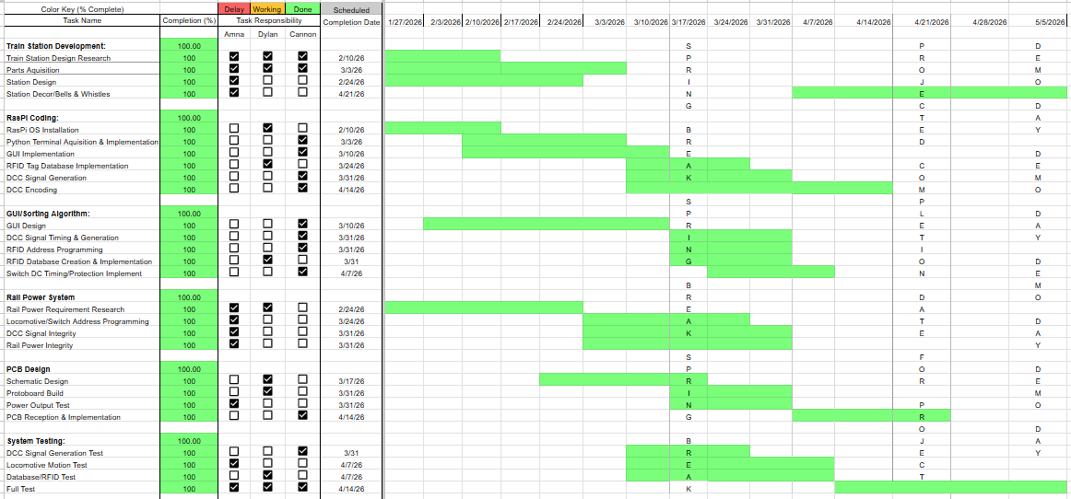

Appendix B: Budget
Below is the project budget estimate for the automated train sorting system. The table summarizes expected costs for materials, electronics, and other components required for system development.
